create database 1bm21cs052_Bank1;

use 1bm21cs052_Bank1;

create table branch(

branch_name varchar(20),

branch_city varchar(10),

assets real,

PRIMARY KEY(branch_name)

);

create table bankCustomer(

customer_name varchar(20),

customer_street varchar(20),

customer_city varchar(15),

PRIMARY KEY(customer_name)

);

create table bankAccount(

accno int,

branch_name varchar(20),

balance real,

PRIMARY KEY(accno),

FOREIGN KEY(branch_name) REFERENCES branch(branch_name)

ON UPDATE CASCADE ON DELETE CASCADE

);

create table loan(

loan_no int,

branch_name varchar(20),

amount real,

PRIMARY KEY(loan_no),

FOREIGN KEY(branch_name) REFERENCES branch(branch_name)

ON UPDATE CASCADE ON DELETE CASCADE

);

create table depositer(

customer_name varchar(20),

accno int,

FOREIGN KEY(customer_name) REFERENCES bankCustomer(customer_name)

ON UPDATE CASCADE ON DELETE CASCADE,

FOREIGN KEY(accno) REFERENCES bankAccount(accno)

ON UPDATE CASCADE ON DELETE CASCADE

);

insert into branch values('sbi_chamrajpet','bangalore',50000);

insert into branch values('sbi_residencyRoad','bangalore',10000);

insert into branch values('sbi_shivajiRoad','bombay',20000);

insert into branch values('sbi_parliamentRoad','delhi',10000);

insert into branch values('sbi_jantarMantar','delhi',20000);

insert into branch values('sbi_mantrimarg','delhi',200000);

insert into bankAccount values(1,'sbi_chamrajpet',2000);

insert into bankAccount values(2,'sbi_residencyRoad',5000);

insert into bankAccount values(3,'sbi_shivajiRoad',6000);

insert into bankAccount values(4,'sbi_parliamentRoad',9000);

insert into bankAccount values(5,'sbi_jantarMantar',8000);

insert into bankAccount values(6,'sbi_shivajiRoad',4000);

insert into bankAccount values(8,'sbi_residencyRoad',4000);

insert into bankAccount values(9,'sbi_parliamentRoad',3000);

insert into bankAccount values(10,'sbi_residencyRoad',5000);

insert into bankAccount values(11,'sbi_jantarMantar',2000);

insert into bankAccount values(12,'sbi_mantrimarg',2000);

insert into bankCustomer values('avinash','bull_temple_road','bangalore');

insert into bankCustomer values('dinesh','bannergatta_road','bangalore');

insert into bankCustomer values('mohan','nationalCollege_road','bangalore');

insert into bankCustomer values('nikil','akbar_road','delhi');

insert into bankCustomer values('ravi','prithviraj_road','delhi');

insert into depositer values('avinash',1);

insert into depositer values('dinesh',2);

insert into depositer values('nikil',4);

insert into depositer values('ravi',5);

insert into depositer values('avinash',8);

insert into depositer values('nikil',9);

insert into depositer values('dinesh',10);

insert into depositer values('nikil',11);

insert into loan values(1,'sbi_chamrajpet',1000);

insert into loan values(2,'sbi_residencyRoad',2000);

insert into loan values(3,'sbi_shivajiRoad',3000);

insert into loan values(4,'sbi_parliamentRoad',4000);

insert into loan values(5,'sbi_jantarMantar',5000);

select branch_name, concat(assets/100000,'lakhs')as asset_in_lakhs

from branch;

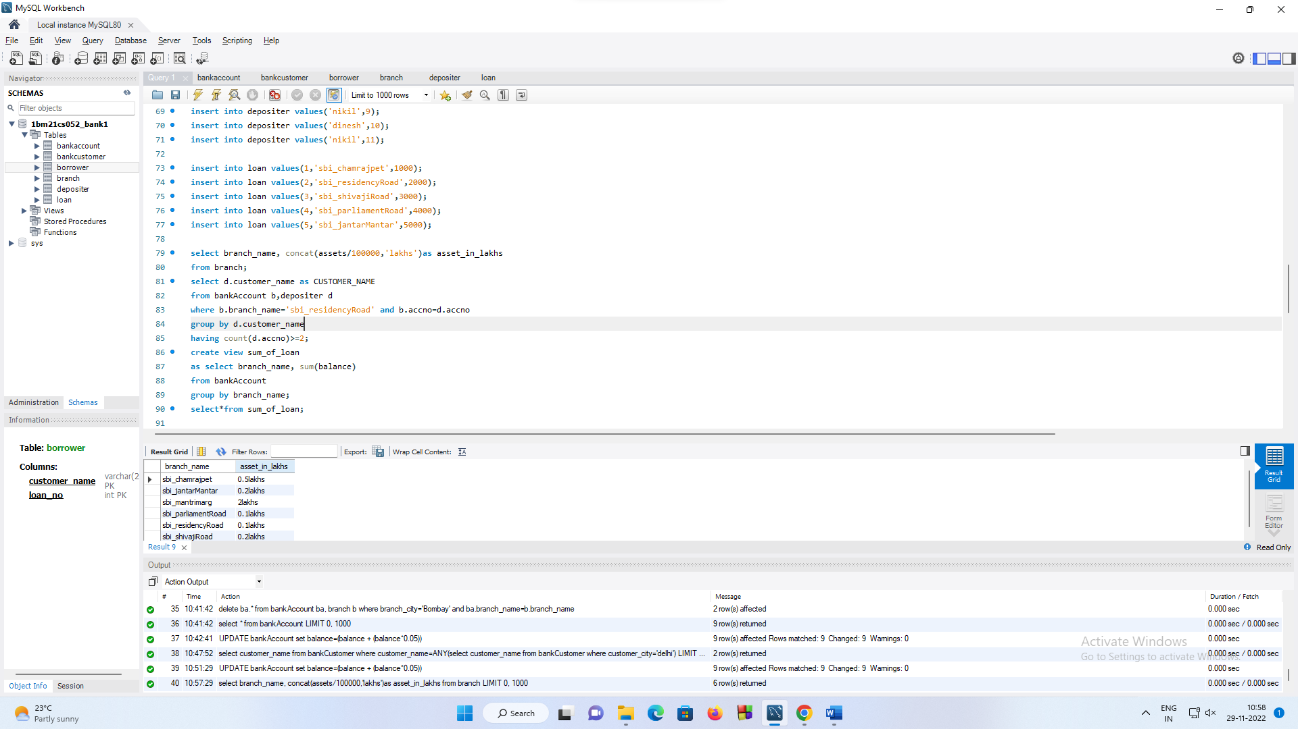

select d.customer_name as CUSTOMER_NAME

from bankAccount b,depositer d

where b.branch_name='sbi_residencyRoad' and b.accno=d.accno

group by d.customer_name

having count(d.accno)>=2;

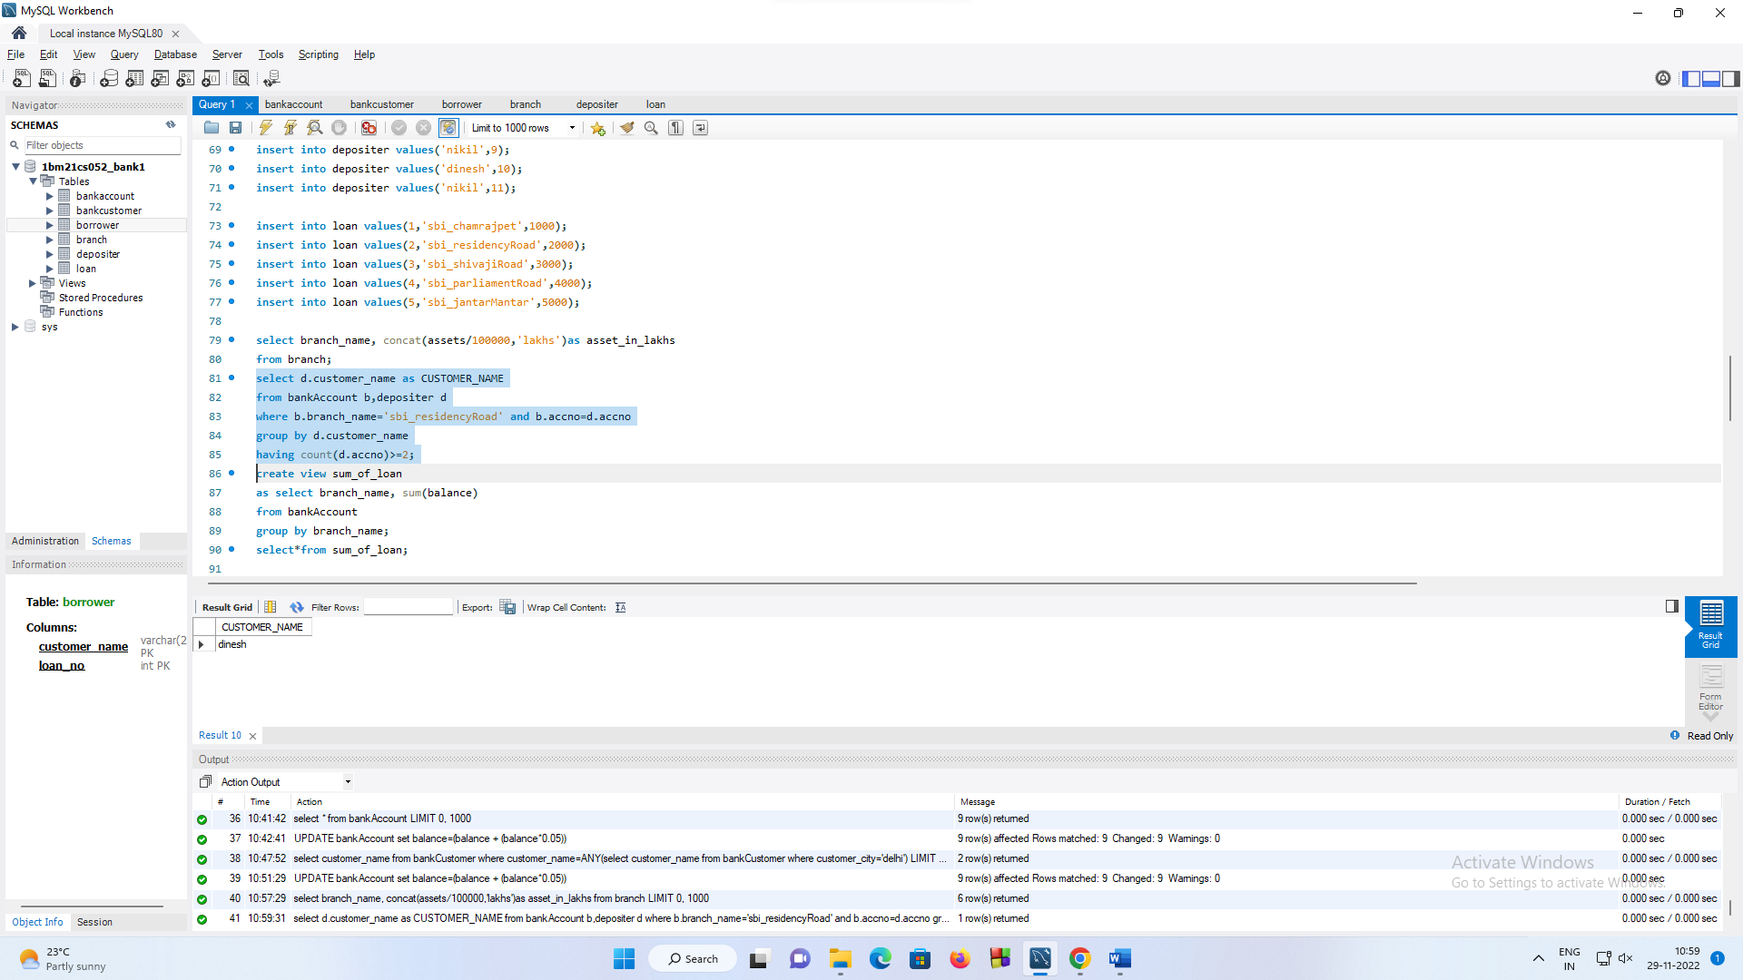

create view sum_of_loan

as select branch_name, sum(balance)

from bankAccount

group by branch_name;

select*from sum_of_loan;

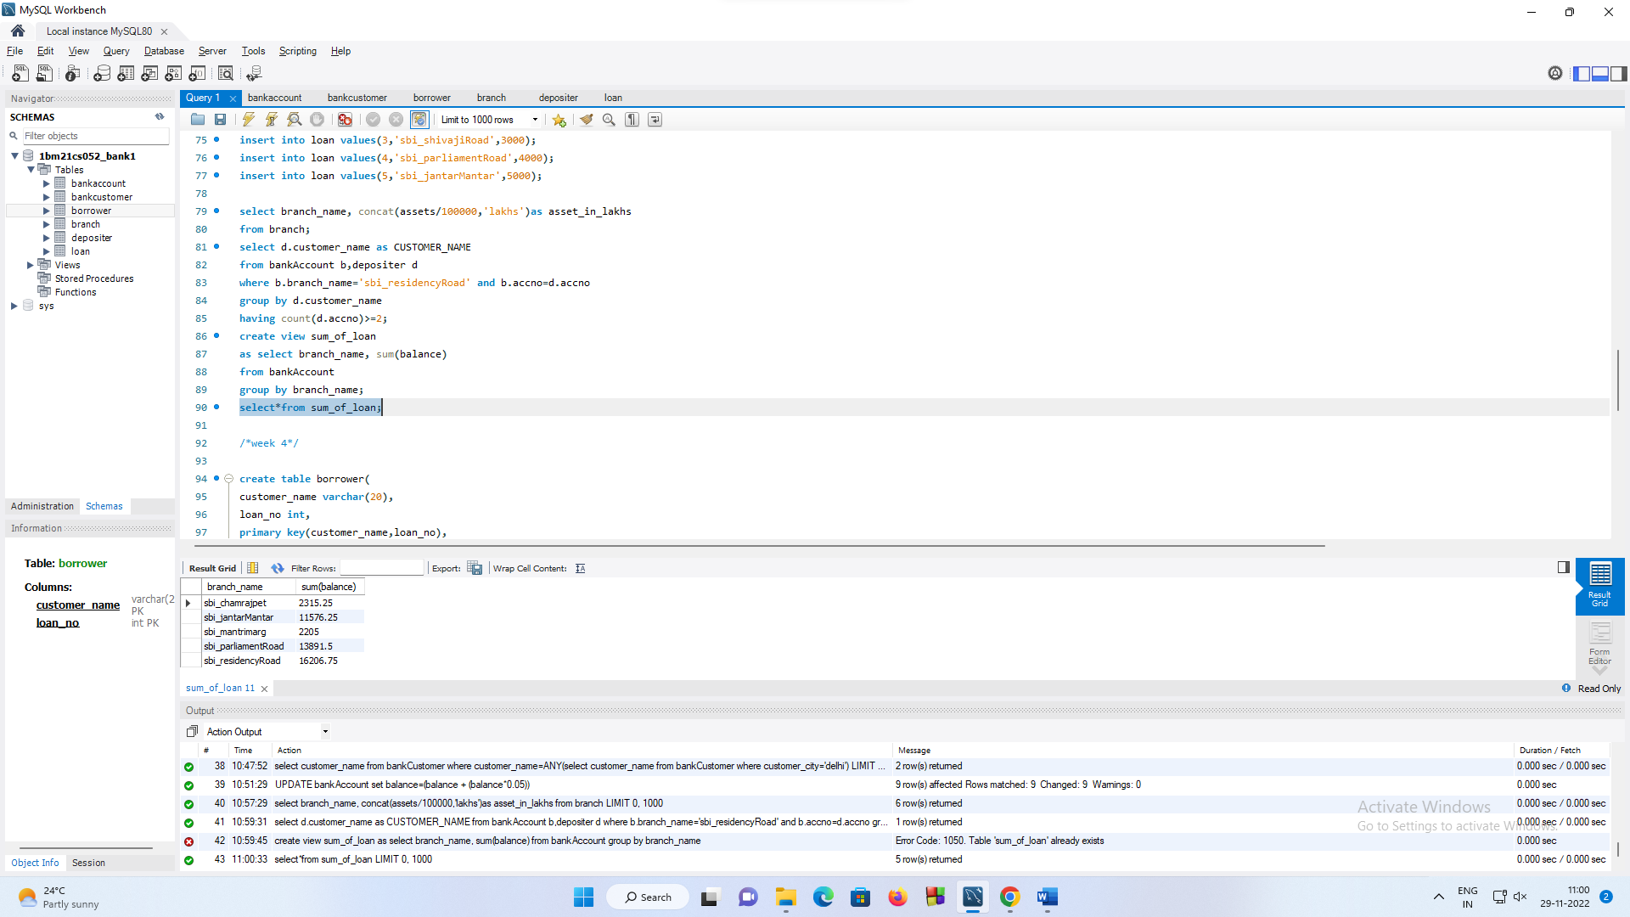

/*week 4*/

create table borrower(

customer_name varchar(20),

loan_no int,

primary key(customer_name,loan_no),

foreign key(loan_no) references loan(loan_no)

);

insert into borrower values('avinash',1);

insert into borrower values('dinesh',2);

insert into borrower values('mohan',3);

insert into borrower values('nikil',4);

insert into borrower values('ravi',5);

select customer_name from bankCustomer

where customer_name=ANY(select customer_name from bankCustomer where customer_city='delhi');

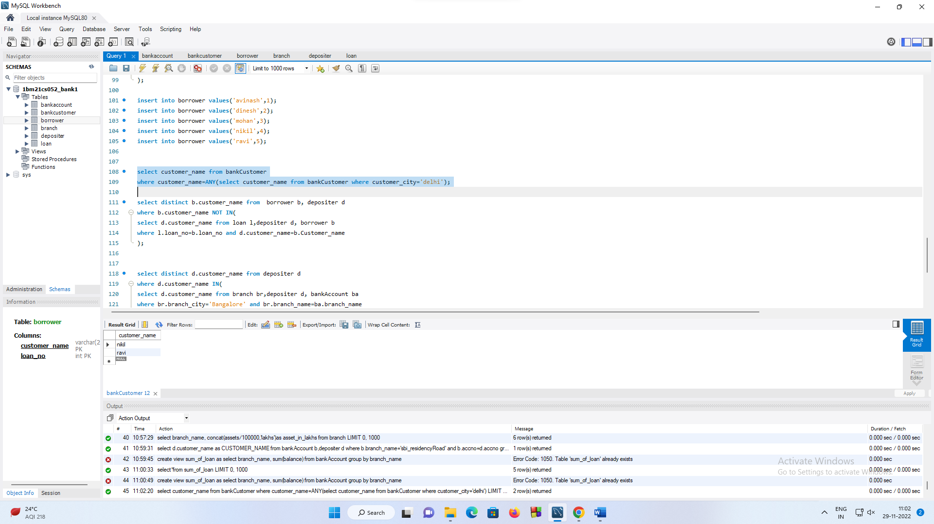

select distinct b.customer_name from borrower b, depositer d

where b.customer_name NOT IN(

select d.customer_name from loan l,depositer d, borrower b

where l.loan_no=b.loan_no and d.customer_name=b.Customer_name

);

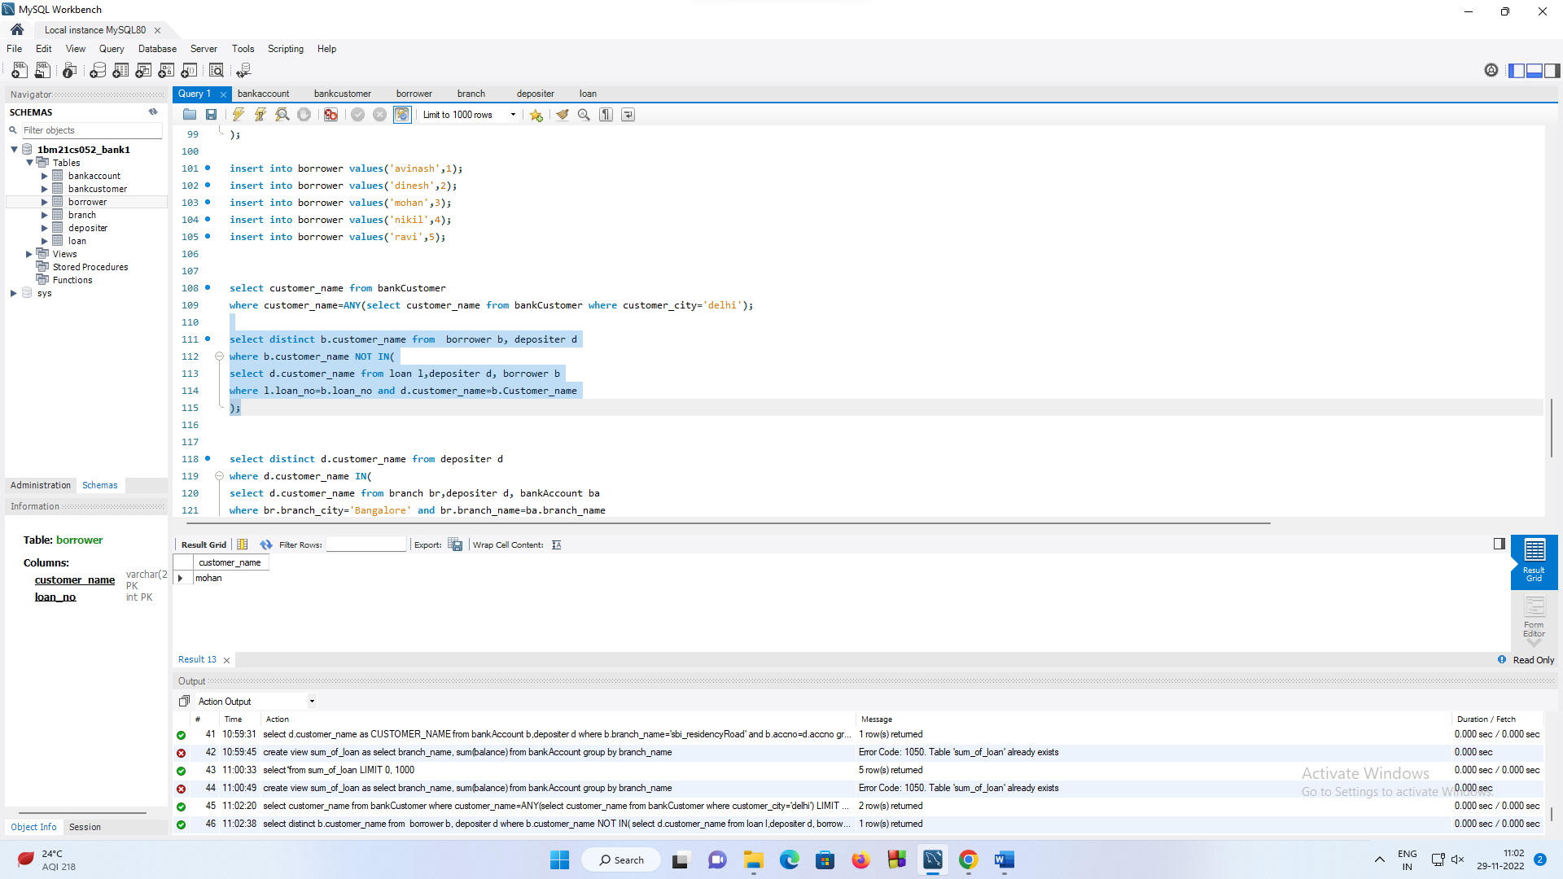

select distinct d.customer_name from depositer d

where d.customer_name IN(

select d.customer_name from branch br,depositer d, bankAccount ba

where br.branch_city='Bangalore' and br.branch_name=ba.branch_name

and ba.accno=d.accno and customer_name IN(

select customer_name from borrower)

);

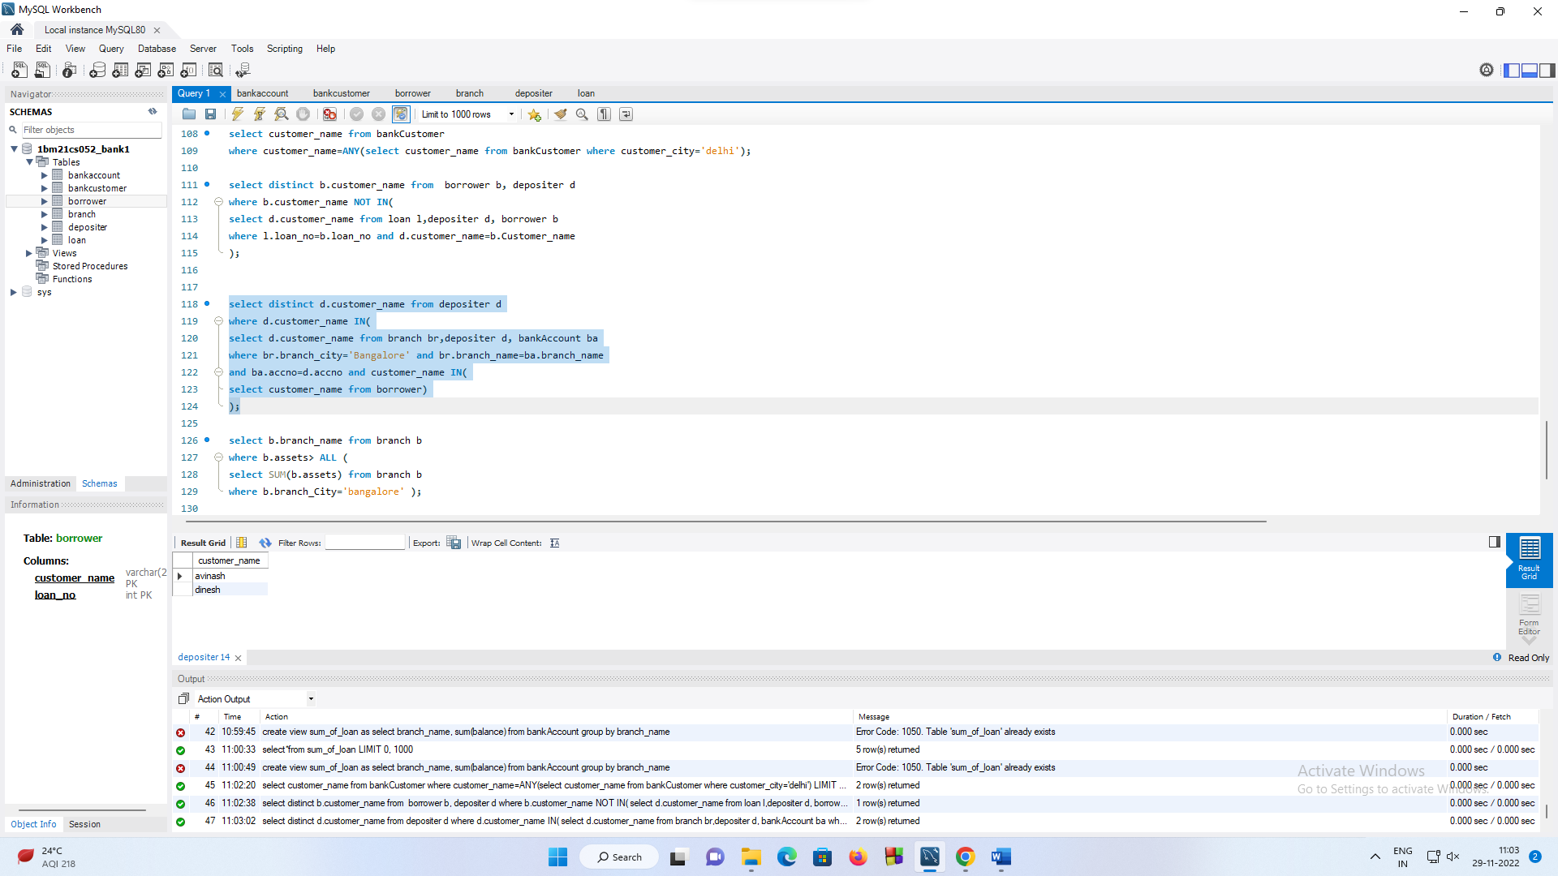

select b.branch_name from branch b

where b.assets> ALL (

select SUM(b.assets) from branch b

where b.branch_City='bangalore' );

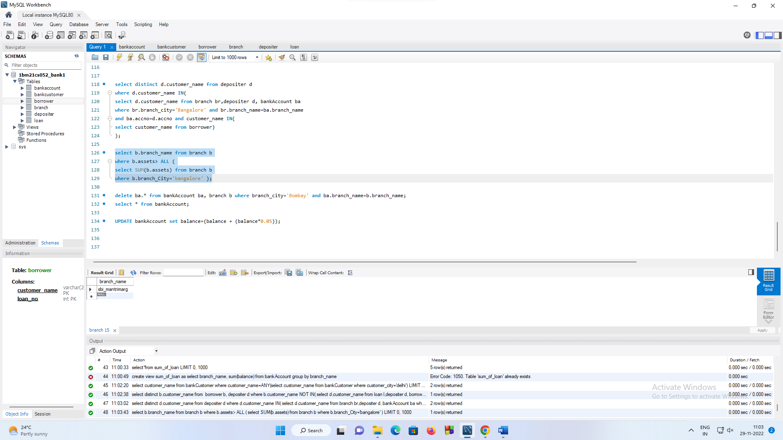

delete ba.* from bankAccount ba, branch b where branch_city='Bombay' and ba.branch_name=b.branch_name;

select * from bankAccount;

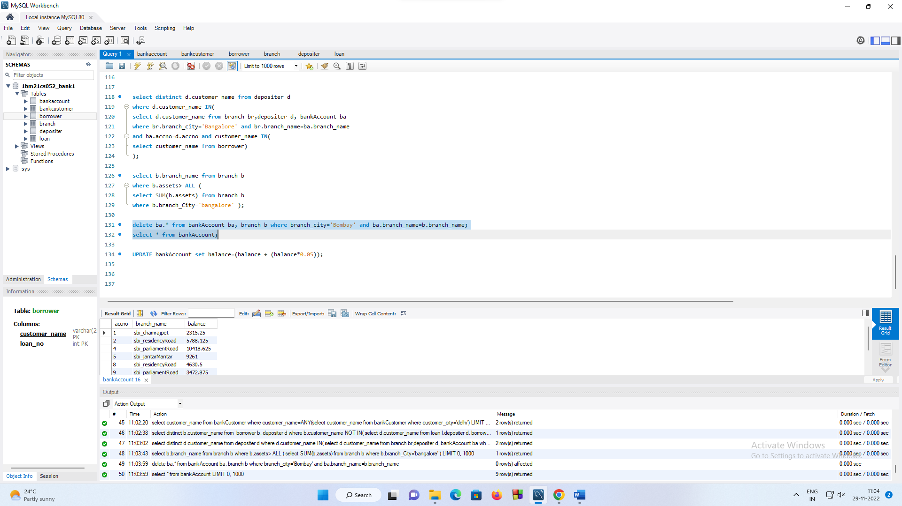

UPDATE bankAccount set balance=(balance + (balance*0.05));

delete from branch where branch_city='bangalore';

select * from branch;

